Dr. BABASAHEB AMBEDKAR MARATHWADA UNIVERSITY,

CHH. SAMBHAJNAGAR,431001



PROJECT REPORT ON

**Line Following Rover**

SUBMITTED BY

**Pranav Madhukar Sirsufale**

**Pratibha Ashok Wagh**

**Shraddha Shahadev Gulajkar**

**Rohan Bhaktpralhad Magar**

**Sunil Ansiram Misal**

MSc CS (1st - Year)

**Subject: Microcontroller Programming Using Python**

YEAR 2024-25

SUBMITTED TO

**Dr. Pravin L. Yannawar**

Department of Computer Science,

Dr. Babasaheb Ambedkar Marathwada University,

Chh. Sambhajinagar.



**Dr. Babasaheb Ambedkar Marathwada University, Chhatrapati**

**Sambhaji Nagar – 431001.**

**NAAC Accredited with ‘A+’**

**Department of Computer Science and Information Technology**

CERTIFICATE

This is to certify that Mr./Mrs./Ku.

He/ She has successfully carried out the all Practical and Assignments of the subject **Microcontroller Programming Using Python** inthe class of **M.Sc. (Computer Science) Sem.-IInd** during the academic year 2024-2025.

**Hence Certified.**

**Seat No.:**

**Date: / /**

**Dr. Pravin L. Yannawar Prof. Ramesh R. Manza**

**Course Co-ordinator Head of The Department**

**Ms. Diksha Pawar Examiner**

**Practical In-Charge**

### **Black Line Following Car Robot**

#### **1. Introduction**

A line-following robot is a self-driving robotic vehicle that can detect and follow a black line on a white surface (or the other way around). These robots are commonly used in industrial automation, warehouses, and robotics competitions to navigate predefined paths efficiently.

#### **Project Overview**

In this project, we will:

* Use infrared (IR) sensors to detect and track a black line.
* Control DC motors to move the robot forward, left, and right as needed.
* Build an Arduino-powered control system to automate movement.

#### **2. Objectives**

The main goals of this project are:

* Designing and developing an autonomous robot that follows a predefined black line.
* Understanding how IR sensors work to distinguish between black and white surfaces.
* Using an Arduino microcontroller to process sensor input and control movements.
* Exploring motor driver circuits and their role in guiding robotic motion.
* Optimizing the navigation system through efficient coding logic for smoother movement.

**Block Digram**

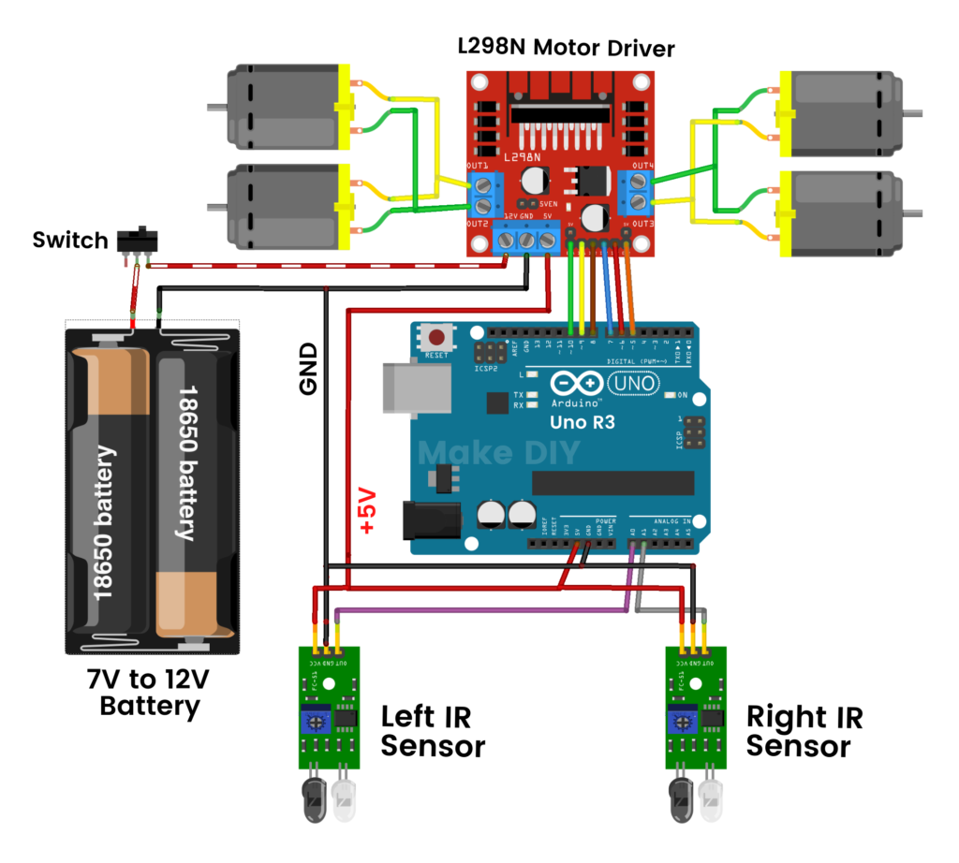

**3. Components Required**

**a) Hardware Components**

**Microcontroller Unit**

* **Arduino Uno/Nano** – Acts as the brain of the robot, processing sensor inputs and controlling motors.

**Sensors**

* **IR Sensors (Infrared Sensors) – 2 units**
  + Used to detect the black line on a white surface.
  + Works by emitting infrared light and detecting its reflection.
  + Black absorbs IR light (no reflection), while white reflects it.

**Motors & Driver**

* **2x DC Motors** – Drive the robot’s wheels forward and sideways.
* **Motor Driver Module (L298N)** – Allows the Arduino to control motor speed and direction.

**Power Supply**

* **9V or 12V Battery** – Provides power to the circuit.
* **Battery Holder** – Securely holds the battery.

**Mechanical Structure**

* **Robot Chassis** – The base frame where all components are mounted.
* **2x Wheels** – Connected to the motors to enable movement.
* **1x Caster Wheel** – Helps balance the car.

**Connecting Components**

* **Jumper Wires** – Used to connect all components.

**4. Working Principle of the Line Following Robot**

1. **IR Sensors detect the black line.**
2. **Arduino reads the sensor values.**
3. **Based on sensor input, Arduino controls the motors:**
   * If both sensors detect black → Move forward.
   * If only the left sensor detects black → Turn right.
   * If only the right sensor detects black → Turn left.
   * If no black detected → Stop.

**5. Circuit Diagram & Connections**

**IR Sensor Connections**

|  |  |
| --- | --- |
| **IR Sensor** | **Arduino Pin** |
| Left Sensor Output | A0 |
| Right Sensor Output | A1 |
| VCC | 5V |
| GND | GND |

**Motor Driver (L298N) Connections**

|  |  |
| --- | --- |
| **Motor Driver (L298N)** | **Arduino Pin** |
| IN1 | 9 |
| IN2 | 10 |
| IN3 | 11 |
| IN4 | 12 |
| Motor A (Left Motor) | L298N OUT1, OUT2 |
| Motor B (Right Motor) | L298N OUT3, OUT4 |
| VCC | 9V-12V Battery |
| GND | GND |

**6. Step-by-Step Implementation**

**Step 1: Assembling the Robot Chassis**

* Attach the two DC motors to the base.
* Fix two wheels onto the motor shafts.
* Place the caster wheel at the front or back for balance.

**Step 2: Mounting the IR Sensors**

* Attach two IR sensors to the front bottom of the chassis.
* Ensure one sensor is on the left side and the other on the right side.
* The sensors should be slightly above the surface (5mm - 10mm).

**Step 3: Wiring the Components**

* Connect the IR sensors to the Arduino (A0 & A1).
* Connect the motor driver to the Arduino and DC motors.
* Connect the battery to power the system.

**Step 4: Uploading the Arduino Code**

* Open Arduino IDE.
* Write the code to read sensor values and control motors.
* Upload the code to the Arduino board.

**7. Arduino Code for Line Follower Robot**

// Define IR sensor pins

#define leftSensor A0

#define rightSensor A1

// Define Motor Driver Pins

#define motor1A 9

#define motor1B 10

#define motor2A 11

#define motor2B 12

void setup() {

pinMode(leftSensor, INPUT);

pinMode(rightSensor, INPUT);

pinMode(motor1A, OUTPUT);

pinMode(motor1B, OUTPUT);

pinMode(motor2A, OUTPUT);

pinMode(motor2B, OUTPUT);

}

void loop() {

int left = digitalRead(leftSensor);

int right = digitalRead(rightSensor);

if (left == 0 && right == 0) {

moveForward();

} else if (left == 1 && right == 0) {

turnRight();

} else if (left == 0 && right == 1) {

turnLeft();

} else {

stopMotors();

}

}

void moveForward() {

digitalWrite(motor1A, HIGH);

digitalWrite(motor1B, LOW);

digitalWrite(motor2A, HIGH);

digitalWrite(motor2B, LOW);

}

void turnRight() {

digitalWrite(motor1A, LOW);

digitalWrite(motor1B, LOW);

digitalWrite(motor2A, HIGH);

digitalWrite(motor2B, LOW);

}

void turnLeft() {

digitalWrite(motor1A, HIGH);

digitalWrite(motor1B, LOW);

digitalWrite(motor2A, LOW);

digitalWrite(motor2B, LOW);

}

void stopMotors() {

digitalWrite(motor1A, LOW);

digitalWrite(motor1B, LOW);

digitalWrite(motor2A, LOW);

digitalWrite(motor2B, LOW);

}

**8. Expected Output**

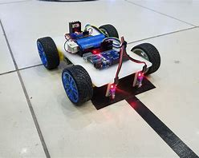 The robot moves forward along the black line.

* If the left sensor detects white, the car turns right.
* If the right sensor detects white, the car turns left.
* If no black line is detected, the robot stops.

**9. Future Scope & Enhancements**

**Avoid obstacle -** In order to detect objects or obstacle in the path use/add ultrasonic sensors

**Control over speed –** Implement PID control for smooth movement.  
**Wireless Control** – Use Bluetooth/WiFi for remote operation.  
**AI & Computer Vision** – Use OpenCV & Camera for smart navigation.  
**Industrial Applications** – Automate warehouse robots for transportation.

**10. Conclusion**

This Black path following Rover is a simple but good project in order to understand robotics, controls , sensors and automation. It can be further developed into AI-Powered vehicle for smart applications.

**11.Future scope**

The **Black Line Following Car Robot** has a bright future in:

1. **Industrial Automation** – Used in factories and warehouses for material transport.
2. **Public Transport** – Can guide autonomous buses and trains.
3. **Healthcare** – Helps in hospitals for medicine and supply delivery.
4. **Smart Agriculture** – Assists in crop monitoring and automated farming.
5. **Military & Defense** – Used for unmanned transport in risky areas.
6. **Education & Research** – Enhances learning in robotics and AI.

With AI and IoT, these robots are evolving into **fully autonomous systems** for real-world applications.